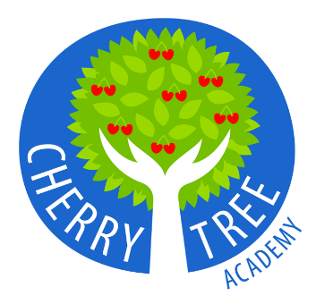

**Cherry Tree Academy**

**Information about Disabled Access**

Schools and the Education Authority must not discriminate against pupils with special educational needs for a reason relating to their disability. They should promote the inclusion of special educational needs pupils in their admission arrangements and in all aspects of school life.

|  |
| --- |
| **Accessibility Plans and Reasonable Adjustments** |
| Schools vary widely in how accessible they are to pupils. You should check what improvements have been made to a school and what is being planned when considering a school for your child. Every school must have an accessibility plan, which shows how they intend to improve accessibility for special educational needs pupils, and when. For Cherry Tree Academy, this can be found on the school website. The plan must be published and you can ask to see it. It will outline how the school will:     * improve the physical environment * make improvements in the provision of information * increase access to the curriculum   Schools can also increase access for individual pupils by making ‘reasonable adjustments’. These can be simple changes, such as making sure that all lessons take place in ground floor classrooms, for a class, where one of the pupils uses a wheelchair and the school does not have a lift. You should always talk to a school to discuss what it can reasonably do to include your child. |
| **Improvements in the Physical Environment** |
| Changes to the physical environment that a school could make to increase access might include:   * lighting and paint schemes to help visually impaired children * lifts and ramps to help the physically needs and/or disability of children * carpeting and acoustic tiling of classrooms to help hearing impaired pupils |
| **Improving The Way Information Is Delivered To Pupils With Disabilities** |
| Information that is normally provided in writing (such as handouts, timetables and textbooks) can be made more accessible by providing it:   * in Braille * in large print * on audio format |
| **Understanding the Curriculum** |
| Adjustments that would help children with disabilities have better access to the curriculum might include:   * changes to teaching and learning arrangements * classroom organisation * timetabling * support from other pupils |
| **Assistive Technology** |
| Technology suited to a child's needs can help them learn faster and more easily. Examples of technology that can help include:   * touch-screen computers, joysticks and tracker balls * easy-to-use keyboards * interactive whiteboards * text-to-speech software * Braille-translation software   Schools may already have this kind of technology available, or may be planning to get it. Arrangements for distributing resources and funding for equipment vary throughout the UK. If your child has an Education Health Care Plan (EHCP), the support required, is detailed on their plan (which may include special equipment). |
| **School Transport** |
| While the same basic rules apply to all children, the Education Authority can make a decision to provide transport on a case by case basis for a child with disabilities. Your Education Authority region office will assess your child's needs when making a decision, taking into account your child's health and/or disability. If your child is offered school transport, the vehicle should have the relevant equipment to suit your child's needs - for example wheelchair restraints, ramps or lifts. For more detailed information, about approved transport arrangement, please refer to Wakefield Local Authority –   * <https://www.wakefield.gov.uk/schools-and-children/special-education-needs-sen/support-for-families-with-disabled-children> * <https://www.wakefield.gov.uk/schools-and-children/schools/going-to-school/travel-transport/school-transport> |
| **If Your Child Cannot Attend For Medical Reasons** |
| If your child cannot go to school because of medical needs or health problems, the Education Authority has a responsibility to enable them to continue their education. This could be achieved by lessons in Hospital, for example, or a Flexi-School Arrangement, which would be agreed and put in place with the Local Authority SEND Team and the Admissions Department. |
| **Physical Needs and/or Disability Access** **Provision at Cherry Tree Academy** |
| Cherry Tree Academy is able to support most children with physical needs and/or disabilities.  We have a disabled toilet which provides adequate space for a person’s wheelchair.  Key entry and exit points are all on ground level. |