Cherry Tree Academy
Long Term English Planning Cycle A

EYFS | Core Texts | Autumn |  | Spring |  | Summer
 |  | 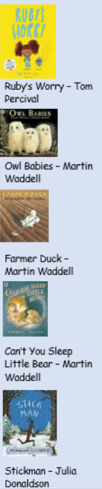 | 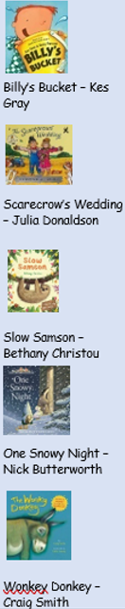 | 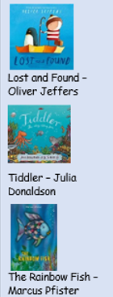 | 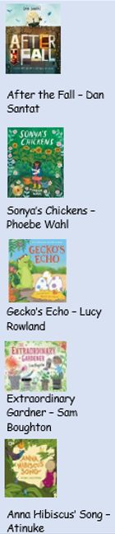 | 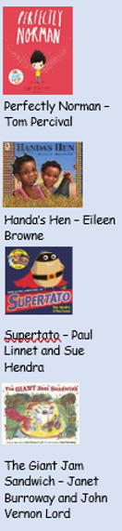 | 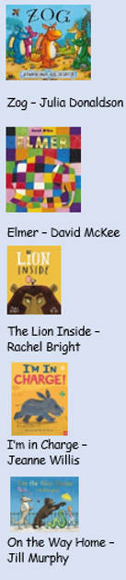
 | Key vocabulary | Explore, discover, wonder, emourmous, barely, unexpected, shrink, tumble  Hunt, silent, fuss, bounced, brave, flap  Crept, wriggle, creak, wearily, fled, squeezed  Settle, groan, curl, glow, hook, twinkly, puzzle, cosy  Twirl, tumbling, sharp, weary, chuckle, doze, clattering, drifts | Explained, persuaded, sighed, excitedly, special, chuckled, frowned, imagination  Hunt, spotted, hurried, gathered, certain, exclaimed, staggering, sprinkled  Arrived, distracted, charged, annoyed, sobbed, received, noted, lonley  Cosy, miserable, snuggled, shivering, shoved, scraping, fierce, chuckle  Immeditely, hurling, dragged, staggered, squealed, panic, plunged, struggled | Ignored, floated, disappointment, discovered, delighted, lonely, searched, wonderful.  Captured, struggled, dawdling, hauling, glimmering, shivered, peeped, bashed  Sparkling, glide, admire, emerged, discover, peculiar, whizzed, delighted | Eventually, famous, grand, fortunately, admit, perfect, terffified  Spruced, tending, nestled, ruckus, crept, cowering, exhausted  Brave, muttered, spied, scampered, beware, boomed, crept, precious  Imagination, wild, ordinary, roamed, soared, longed, discovered  Amazing, pound, scattering, floats, chuckles, explode, reasons | Extraordinary, uncomfortabl, swooping, miserable, hesitantly, problematic, wonderful, nervously  Hunted, fluttery, peered, waving, shiny, peeped, scurried, skipped  Escaped, gasped, rescue, distress, vanished, crept, leapt, shrieked  Nuisance, mighty, leaped, spoil, swelled, squealed, humming, dived | Gripping, wildly, fearsome, expert, crowded, triumph, soared, roared  Slipped, absolutely, serious, burst, gasped, celebrate, decorate  Sparkled, mighty, craggy, meek, whimpered, ignored, impressed, slumbering  Bellowed, startled, barged, sneaked, grinned, dreadful, stomped, refused  Sneaking, gasped, crammed, soaring, vast, gloomy, slithering, struggled
 | Writing purpose | Child initiated opportunities for writing in indoor and outdoor provision areas that give opportunities to:  *Write narrative about personal experiences and those of others (real and ficitonal)  *Write about real events  *Write poetry  *Write for different purposes
 | Writing skills grammar and punctuation | Orally speak in full sentences. | Orally rehearse captions and sentences before writing them down. | Orally rehearse a sentence before writing it down.  Begin the practise ‘Think a sentence, Say a sentence, Write a sentence’ | Orally rehearse a sentence before writiting it down sometimes using a capital letter and a full stop.  Develop ability to ‘Think a sentene, say a sentence, write a sentence’ and begin to ‘check a sentence’. | Orally rehearse a sentence before writiting it down sometimes using a capital letter and a full stop.  Develop ability to ‘Think a sentene, say a sentence, write a sentence and check a sentence’. | Orally use the conjucntion and in sentences.  Orally rehearse a sentence before writiting it down sometimes using a capital letter and a full stop.  Develop ability to ‘Think a sentene, say a sentence, write a sentence and check a sentence’.
 |  | Spelling taught in line with RWI phonics progression.
 | Spelling | Write the first 16 single set 1 letter sounds. | Write all single letter set 1 letter sounds.  Hear the sounds in CVC words. | Write all single letter set 1 letter sounds.  Use these know sounds to write CVC words. | Write the 4 double consonants.  Write CVC, CCVC, and CVCC words using sounds they know.  Spell common exception ‘red storybook’ words. | Write CVC, CCVC and CVCC words using sounds they know.  Spell common exception ‘red storybook’ words. | Write the first 6 set 2 sounds and use these to spell words.  Write CVC, CCVC and CVCC words using sounds they know.  Spell common exception ‘red storybook’ words
 | Reading Skills | Reading skills taught through RWI phoincs and storybook sessions alongide ‘Talk Through Stories’ for comprehension and vocabulary development.
 |  | Read single-letter set 1 sounds (first 16). | Read all set 1 single letter sounds.  Blend sounds into words orally. | Blend sounds to read words.  Read short Ditty stories. | Read Red Storybooks.  Read 4 double consonants. | Read Green Storybooks. | Read Green or Purple storybooks.  Read fisrt 6 set 2 sounds.

 |  | Autumn |  | Spring |  | Summer
Year 1 /2 | Core Text Writing | 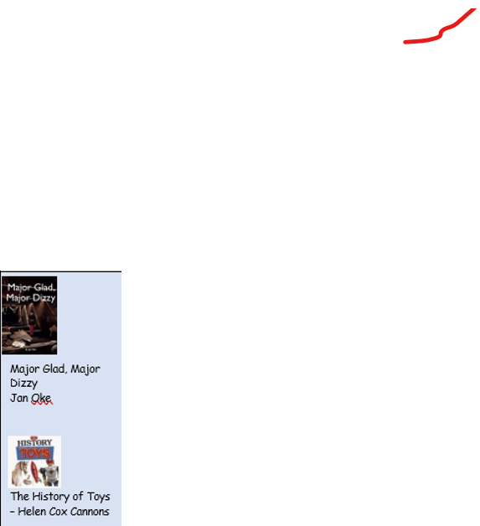 | 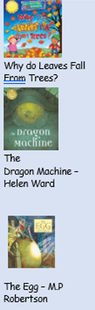 | 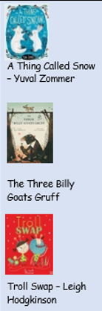 | 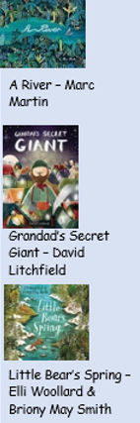 | 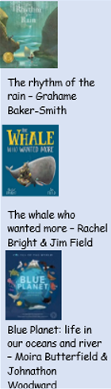 | 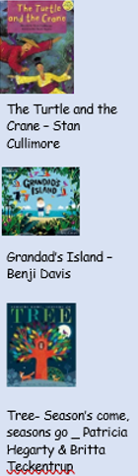
 | Writing Purpose | Entertain  Describe  Inform | Recount  Entertain  Inform  Instruct  Describe | Recount  Describe  Entertain  Inform / Persuade | Recount  Describe  Inform/persuade  Entertain | Inform  Describe  Entertain  Inform | Recount  Describe  Inform  Instruct
 | Writing Outcomes | Narrative – retelling parts of the story  Setting description  Character description  Report (Y1 captions and labels) | Autumn Walk recount  Narrative – story re-tell  Letter  Instructions – how to hatch an egg  Setting description | Winter walk recount  Character description  Narrative – retell  Letter | Spring walk recount  Setting description  Letter  Narrative - retell | Diary entry / Letter  Setting description  Story re-tell  Report | Summer walk recount  Setting description  Report  Instructions – how to get to Grandad’s Island  Postcard
 | Key Vocabulary Y1 | Knock, stole, rattle, shook, shiver, vanish | Ignore, perch, sank, tick, rattle, delight, sizzle, swoop | Leap, nibble, yelp, tug, chuckle, frown, squelch, swap | Stretch, valley, peer, gaze, shore, sharp, terrify, sigh | Plunge, vast, glitter, stir, ripple, drift, quest, root, cram | grumble, burst, attic. Deck, horizon, smooth, shack
 | Key Vocabulary  Y2 | Knock, stole, rattle, shook, bulge, shiver, dainty, private, empire, vanish, cease, monstrous | Unseen, ignore, overlook, perch, sank, troublesome, consult, capture, lumber, tick, click, whir, rattle, clunk, clatter, venture, bargain, rumble, chirrup, delight, distress, defeat, longing, sizzle, beat, perch, clamber, soar, swoop, gape | Leap, twitch, prick, venture, nibble, bound, shimmer, yelp, tumble, scramble, quiver, squirt, tug, trot, chuckle, frown, twirl, crouch, burst, fling, ram, squelch, disgust, swap | Stretch, swept, horizon, grind, plumes, patchwork, valley, murmur, peer, gaze, mumbled, shore, sharp, scoff, humongous, terrify, pickle, sigh, hoist | Plunge, swell, wind, current, steams, grateful, vast, glitter, stir, hubbub, ripple, amass, lonesome, drift, stud, quest, pulled at his heart, life-longing, rifle, root, haul, chaos, cram, bicker, quick wit, eternal, gripe, plunge, brawl | Grumble, cast, agree, wither, burst, attic, deck, lurch, smooth course, horizon, shore, shack, shipshape, chug, churn, prise
 | Grammar and Punctuation Y1 | Magic 5 sentences – capital letters, finger spaces, full stops, sense  Writing structure rehearsal (think a sentence, say a sentence, write a sentence, check a sentence)  word classes - nouns | Magic 5 sentences – capital letters, finger spaces, full stops, sense  Writing structure rehearsal (think a sentence, say a sentence, write a sentence, check a sentence)  word classes – nouns, adjectives | Magic 5 sentences – capital letters, finger spaces, full stops, sense  Writing structure rehearsal (think a sentence, say a sentence, write a sentence, check a sentence)  Word classes – nouns, adjectives | Magic 5 sentences – capital letters, finger spaces, full stops, sense  Writing structure rehearsal (think a sentence, say a sentence, write a sentence, check a sentence)  Word classes – nouns, adjectives  Question marks | Magic 5 sentences – capital letters, finger spaces, full stops, sense  Writing structure rehearsal (think a sentence, say a sentence, write a sentence, check a sentence)  Word classes – nouns, adjectives  Exclamation marks | Magic 5 sentences – capital letters, finger spaces, full stops, sense  Writing structure rehearsal (think a sentence, say a sentence, write a sentence, check a sentence)  Word classes – nouns, adjectives  Exclamation marks
 | Grammar and Punctuation Y2 | Magic 5 sentences – capital letters, finger spaces, full stops, sense  Writing structure rehearsal (think a sentence, say a sentence, write a sentence, check a sentence)  conjunction ‘and’  word classes nouns, adjectives, verbs  Conjunction because  Expanded noun phrases | conjunction ‘and’  word classes - nouns, adjectives, verbs  conjunctions ‘but, so’  conjunctions ‘because, when’  question sentences  time adverbials  past tense sentences | conjunction ‘and’  word classes - nouns, adjectives, verbs  conjunctions ‘but, so’  conjunctions ‘because, when’  question sentences  exclamation sentences  statement sentences  commas in a list  present tense sentences | conjunction ‘and’  word classes - nouns, adjectives, verbs, adverbs  conjunctions ‘but, so’  conjunctions ‘because, when’  question sentences  exclamation sentences  statement sentences  command sentences  commas in a list  past tense sentences | conjunction ‘and’  word classes - nouns, adjectives, verbs, adverbs  conjunctions ‘but, so’  conjunctions ‘because, when’  question sentences  exclamation sentences  statement sentences  commas in a list | conjunction ‘and’  word classes - nouns, adjectives, verbs, adverbs  conjunctions ‘but, so’  conjunctions ‘because, when’  question sentences  exclamation sentences  statement sentences  commas in a list  possessive apostrophe
 | Spelling Y1 | Sounds and Spelling Patterns Covered Progressively Through RWI Phonics Programme
 | Spelling Y2 | Words ending in ff, ll, ck, ss, zz, ve  S and es endings  suffix ‘ed’ with all rules.  Revisiting Y1 CEWs | Prefix ‘un’  Homophones and near homophones  ‘I’ spelt ‘y’ at the end of words.  ‘kn’ and ‘gn’  ‘wr’  Revisiting Y1 CEWs | Suffixes ‘ed’ ‘ing’ ‘er’  Y2 CEWs | Suffixes ‘er’ ‘est’  le, il, al at the end of words  Y2 CEWs | ‘s’ spelt ‘c’  ‘or’ spelt ‘a’  Contraction words  Suffixes ‘ful’ ‘less’ ‘ment’ ‘ness’  Y2 CEWs | Suffix ‘ly’  tion  ‘ee’ spelt ‘ey’  ‘er’ spelt ‘or’  Possessive apostrophe  Y2 CEWs
 | Reading Y1 | Following RWI Phonics and Story Book Sessions
 |  | Read Purple Storybooks.  Read Set 2 sounds. | Read Pink Storybooks.  Read 9 Set 3 sounds. | Read Orange storybooks.  Read 17 set 3 sounds. | Read Yellow Storybooks  Read all Set 3 sounds and additional graphemes (e-e, ie, ue, au, kn, wh, ph) | Read Yellow Storybooks. | Read Blue Storybooks.
 | Core Reading Text Y2 | 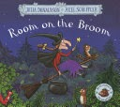  The Room on the Broom  Julia Donaldson  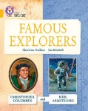  Famous Explorers  Collins Big Cat  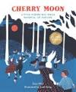  Cherry Moon Poetry- Life is Big | 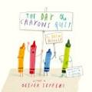  The Day the Crayons Quit  Drew Daywalt  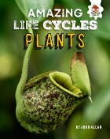  Amazing Life Cycles Plants  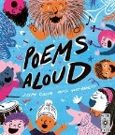  Poems Aloud - Feelings | 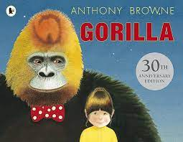  Gorilla  Anthony Browne  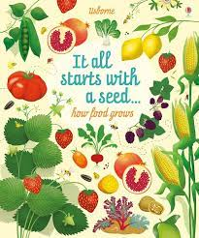  It all Starts with a Seed  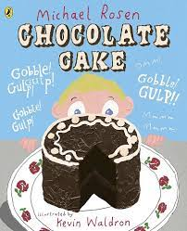  Chocolate Cake – Michael Rosen | 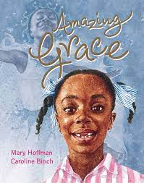  Amazing Grace  Mary Hoffman  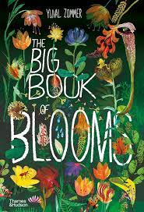  The Big Book of Blooms  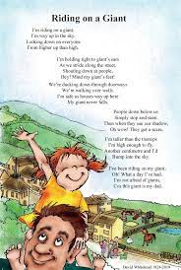  I’m Riding on a Giant | 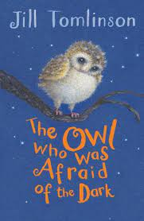  The Owl who was Afraid of the Dark  Jill Tomlinson  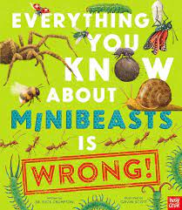  Everything you know about mini-beasts is wrong  Spider Web Mornings | 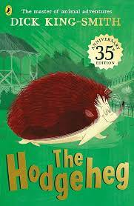  The Hodgeheg  Dick King-Smith  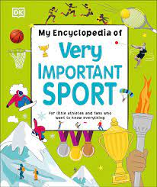  Very Important Sport
 | Reading Skills Y2 | - Continue to apply phonic knowledge and skills as the route to decode words until automatic decoding has become embedded and reading is fluent.  - Read accurately by blending the sounds in words that contain the graphemes taught so far, especially recognising alternative sounds for graphemes.  - Read accurately most words of two or more syllables that contain the same graphemes as above.  - Read further common exception words, noting unusual correspondences between spelling and sound and where these occur in the word.  - Read words containing common suffixes.  - Discuss and clarify the meanings of words, linking new meanings to known vocabulary.  - Discuss their favourite words and phrases.  - Recognise recurring language in stories and poems.  - Learn Tier Two Vocabulary through reading lessons and use this vocabulary orally and in written sentences.  - Read most words quickly and accurately, without overt sounding and blending, when they have been frequently encountered.  - Read aloud books closely matched to their improving phonic knowledge, sounding out unfamiliar words accurately, automatically and without undue hesitation.  - Re-read books that are consistent with their improving phonic knowledge, to build up their fluency and confidence in word reading.  - Recite some poems leant by heart with appropriate intonation to make the meaning clear.  - Draw on what they already know or on background information and vocabulary provided by the teacher.  - Discussing the sequence of events in books and how items of information are related.  - Re-tell using a wider variety of story language.  - Order events from the text.  - Begin to discuss how events are linked focusing on the main content of the story.  • Check that the text makes sense to them as they read and correcting inaccurate reading.  - Participate in discussion about books, poems and other works that are read to them and those that they can read for themselves, taking turns and listening to what others say.  • Explain and discuss their understanding of books, poems and other material, both those that they listen to and those that they read for themselves.  - Express own views about a book or a poem.  - Discuss some similarities between books.  • Ask and answer questions.  - Predict what might happen on the basis of what has been read so far.  - Make predictions using their own knowledge as well as what has happened so far to make logical predictions and give explanations of them.  - Make inferences on characters’ feelings using what they say and do.  - Infer basic points and begin, with support to pick up on more subtle references.  - Use pictures or words to make inferences.  - Independently read and answer simple questions about what they have just read.  - Ask and answer retrieval questions.

Year 3/4 |  | Autumn |  | Spring |  | Summer
 | Core Text Writing | 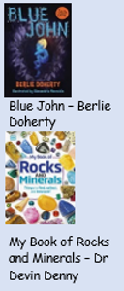 | 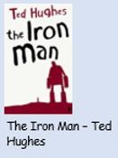 | 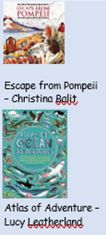 | 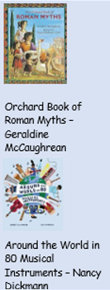 | 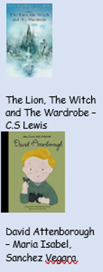 | 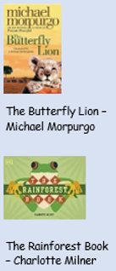
 | Writing Purpose | Describe | Entertain  Instruct | Describe  Entertain  Inform | Describe  inform | Entertain  Inform / persuade | Entertain  inform
 | Purpose and Audience | Setting description  Character description | Narrative retell  Instructions | Character description  Narrative  Report | Character description  Non-chronological report | Narrative  Brochure  Poetry | Letter  Narrative  Report
 | Key Vocabulary Y3 | Force, gush, lock, crack, surge, hollow, tunnel, mine, drawn, sorrow, tearful, heartbroken, seep, promise, skid, sprawl, crawl, tumble, cave, cavern, stalactite, stalagmite, fossil, limestone, glacier, mountain | Blaze, clang, crane, creep, dart, glide, glow, jab, peer, scatter, scuttle, stride, spray, topple, tumble, clatter, gasp, gaze, glare, grind, invite, loom, screech, sneak, vanish, wallow, wander, whirl, gleam, graze, groan, march, sag, strip, tremble, blast, blaze, frown, peer, rumble, weep, wriggle, astonish, battle, droop, flicker, flop, jab, jar, jolt, rage, roast, scatter, scorch, sprawl, wheeze | Glimmer, protect, loom, tremor, weave, strut, bolt, churn, muffle, swell, destroy, explode, blaze | Perch, sprawl, quarrel, tremble, summon, clatter, splutter, bellow, roam, stagger, tumble, graze, declare, regret, wept, tempt, strum, heave, glimpse, snatch, wade, spare, invade, deceive, plunge, flutter, croon, succeed, tend, shift, bombard, plead, loom, brawl, suckle, protes | lure, forgive, sneer, sulk, gild, snigger, plunge, reckon, gloat, fidget, dispute, hoist, start (jump), bay, Grumble, glimpse, pluck, grope, consider, encourage, confront, resume, drift, stoop, betray, spurt, plunge, muffle, shudder, stoop, bundle, tower, glare, summon, perish, leer, surge, | roar, echo, lament, gust, swirl, haul, ramble, smother, spout, pierce, salute, forbid, reply, circle, surround, gather, burst,
 | Key Vocabulary Y4 | Force, mould, gush, lock, crack, surge, billow, hollow, pick, tunnel, mine, drawn, sorrow, grief, tearful, heartbroken, seep, pour, bittersweet, promise, oath, skid, sprawl, crawl, tumble,  cave, cavern, stalactite, stalagmite, fossil, limestone, column, glacier, mountain, chambers, ledge | Blaze, brink, clang, cling, crane, creep, dart, glide, glow, jab, peer, scatter, scuttle, snag, spout, stride, spray, topple, tumble, wheeling, clatter, gasp, gaze, glare, grind, invite, loom, lure, screech, sneak, tower, vanish, wallow, wander, whirl, gleam, graze, groan, grope, march, pound, sag, strip, tremble, unfurl, blast, blaze, blot, char, claw, declare, frown, lament, peer, rumble, weep, wriggle, writhe, astonish, astound, battle, billow, droop, flag, flicker, flop, jab, jar, jolt, plunge, rage, roast, scatter, scorch, scuttle, singe, sprawl, submit, wheeze | Glimmer, protect, loom, haggle, tremor, weave, strut, bray, bolt, churn, muffle, swell, strand, destroy, explode, bray, blaze, repair, rehearse | Perch, sprawl, quarrel, tremble, obey, grant, summon, pitch, clatter, splutter, bellow, roam, stagger, tumble, resolve, graze, declare, defy, forge, marvel, regret, wept, tempt, strum, heave, glimpse, snatch, wade, thrust, founder, spare, nestle, invade, jilt, deceive, plunge, appal, flutter, croon, succeed, conquer, tend, shift, bombard, plead, loom, brawl, shun, suckle, protest, slump | Row, lure, forgive, sneer, jeer, sulk, gild, snigger, fraternizing, burr, plunge, reckon, gloat, abide, fidget, dispute, forfeit, renounce, hoist, start (jump), bay, Grumble, glimpse, wring, bawl, pluck, grope, fumble, consider, encourage, confront, resume, alight, drift, stoop, betray, spurt, plunge, muffle, shudder, remark, bristle, venture, stoop, restore, bundle, tower, glare, summon, perish, halt, leer, conceal, surge, | Scrutinise, roar, echo, sounding, lament, gust, swirl, haul, ramble, smother, spout, pierce, salute, enclose, yearn, forbid, retort, reply, circle, surround, gather, burst,
 | Grammar and Punctuation Y3 | Re-capping Y2 expectations  Magic 5 sentence and writing structure  Commas in a list  Question marks  Exclamation marks  Coordinating conjunctions  Subordinating conjunctions  Word classes  Question sentences  Command sentences  Statement sentences  Exclamation sentences  Expanded noun phrases | Begin to use paragraphs to organise ideas around a theme.  Begin to use inverted commas to punctuate direct speech.  Begin to organise non-narrative work using simple organisational devices e.g. headings and subheadings.  Express time, place and cause using adverbs (for example, then, next, soon, therefore).  Express time, place and cause using conjunctions (e.g. when, before, after, while, so, because). | Begin to use paragraphs to organise ideas around a theme.  Begin to use inverted commas to punctuate direct speech.  Begin to organise non-narrative work using simple organisational devices e.g. headings and subheadings.  Express time, place and cause using adverbs (for example, then, next, soon, therefore).  Express time, place and cause using conjunctions (e.g. when, before, after, while, so, because).  Use the present perfect form of verbs instead of the simple past (e.g. He has gone out to play contrasted with he went out to play). | Use the present perfect form of verbs instead of the simple past (e.g. He has gone out to play contrasted with he went out to play).  Express time, place and cause using prepositions (e.g. before, after, during, in, because, of)  Use conjunctions, adverbs and prepositions to express time and cause.  Begin to use paragraphs to organise ideas around a theme.  Begin to use inverted commas to punctuate direct speech.  Begin to organise non-narrative work using simple organisational devices e.g. headings and subheadings.  Express time, place and cause using adverbs (for example, then, next, soon, therefore).  Express time, place and cause using conjunctions (e.g. when, before, after, while, so, because).  and, because, so, as, or | Use the present perfect form of verbs instead of the simple past (e.g. He has gone out to play contrasted with he went out to play).  Express time, place and cause using prepositions (e.g. before, after, during, in, because, of)  Use conjunctions, adverbs and prepositions to express time and cause.  Begin to use paragraphs to organise ideas around a theme.  Begin to use inverted commas to punctuate direct speech.  Begin to organise non-narrative work using simple organisational devices e.g. headings and subheadings.  Express time, place and cause using adverbs (for example, then, next, soon, therefore).  Express time, place and cause using conjunctions (e.g. when, before, after, while, so, because).  and, because, so, as, or | Use the present perfect form of verbs instead of the simple past (e.g. He has gone out to play contrasted with he went out to play).  Express time, place and cause using prepositions (e.g. before, after, during, in, because, of)  Use conjunctions, adverbs and prepositions to express time and cause.  Begin to use paragraphs to organise ideas around a theme.  Begin to use inverted commas to punctuate direct speech.  Begin to organise non-narrative work using simple organisational devices e.g. headings and subheadings.  Express time, place and cause using adverbs (for example, then, next, soon, therefore).  Express time, place and cause using conjunctions (e.g. when, before, after, while, so, because).  and, because, so, as, or
 | Grammar and Punctuation Y4 | Re-capping on KS1 and Y3 expectations. | Use paragraphs to organise ideas around a theme.  Organise non-narrative work using simple organisational devices e.g. headings and subheadings where appropriate.  Punctuate direct speech accurately, including inverted commas and other punctuation (for example, a comma after the reporting clause; end punctuation within inverted commas).  Use conjunctions, adverbs and prepositions to express time and cause.  Use fronted adverbials to vary sentence structure (e.g. Later that day, I heard the bad news.).  Use commas after fronted adverbials.  Use a wider range of conjunctions, including when, if, because, although to form complex sentences with more than one clause.  Include expanded noun phrases by the addition of modifying adjectives, nouns and preposition phrase. | Use paragraphs to organise ideas around a theme.  Organise non-narrative work using simple organisational devices e.g. headings and subheadings where appropriate.  Punctuate direct speech accurately, including inverted commas and other punctuation (for example, a comma after the reporting clause; end punctuation within inverted commas).  Use conjunctions, adverbs and prepositions to express time and cause.  Use fronted adverbials to vary sentence structure (e.g. Later that day, I heard the bad news.).  Use commas after fronted adverbials.  Use a wider range of conjunctions, including when, if, because, although to form complex sentences with more than one clause.  Include expanded noun phrases by the addition of modifying adjectives, nouns and preposition phrase.  Use the present perfect form of verbs in contrast to the past tense.  Use standard English forms of verb inflections instead of local spoken forms.  Recognise when possessive apostrophe is needed and place it accurately in words with regular plurals and in words with irregular plurals. | Use paragraphs to organise ideas around a theme.  Organise non-narrative work using simple organisational devices e.g. headings and subheadings where appropriate.  Punctuate direct speech accurately, including inverted commas and other punctuation (for example, a comma after the reporting clause; end punctuation within inverted commas).  Use conjunctions, adverbs and prepositions to express time and cause.  Use fronted adverbials to vary sentence structure (e.g. Later that day, I heard the bad news.).  Use commas after fronted adverbials.  Use a wider range of conjunctions, including when, if, because, although to form complex sentences with more than one clause.  and, because, so, as, or  Include expanded noun phrases by the addition of modifying adjectives, nouns and preposition phrase.  Use the present perfect form of verbs in contrast to the past tense.  Use standard English forms of verb inflections instead of local spoken forms.  Recognise when possessive apostrophe is needed and place it accurately in words with regular plurals and in words with irregular plurals. | Use paragraphs to organise ideas around a theme.  Organise non-narrative work using simple organisational devices e.g. headings and subheadings where appropriate.  Punctuate direct speech accurately, including inverted commas and other punctuation (for example, a comma after the reporting clause; end punctuation within inverted commas).  Use conjunctions, adverbs and prepositions to express time and cause.  Use fronted adverbials to vary sentence structure (e.g. Later that day, I heard the bad news.).  Use commas after fronted adverbials.  Use a wider range of conjunctions, including when, if, because, although to form complex sentences with more than one clause.  and, because, so, as, or  Include expanded noun phrases by the addition of modifying adjectives, nouns and preposition phrase.  Use the present perfect form of verbs in contrast to the past tense.  Use standard English forms of verb inflections instead of local spoken forms.  Recognise when possessive apostrophe is needed and place it accurately in words with regular plurals and in words with irregular plurals.  Use pronouns or alternative nouns within and across sentences to aid cohesion and avoid repetition. | Use paragraphs to organise ideas around a theme.  Organise non-narrative work using simple organisational devices e.g. headings and subheadings where appropriate.  Punctuate direct speech accurately, including inverted commas and other punctuation (for example, a comma after the reporting clause; end punctuation within inverted commas).  Use conjunctions, adverbs and prepositions to express time and cause.  Use fronted adverbials to vary sentence structure (e.g. Later that day, I heard the bad news.).  Use commas after fronted adverbials.  Use a wider range of conjunctions, including when, if, because, although to form complex sentences with more than one clause.  and, because, so, as, or  Include expanded noun phrases by the addition of modifying adjectives, nouns and preposition phrase.  Use the present perfect form of verbs in contrast to the past tense.  Use standard English forms of verb inflections instead of local spoken forms.  Recognise when possessive apostrophe is needed and place it accurately in words with regular plurals and in words with irregular plurals.  Use pronouns or alternative nouns within and across sentences to aid cohesion and avoid repetition.
 | Spelling Y3 | -tch (witch)  -dge (fridge)  -ge (orange)  -j spelt g (gem)  -n spelt gn and kn (knee/gnome)  -le (table)  -el (tunnel)  -al (animal)  -il (fossil) | -y making ‘igh’ (fly)  -s, es (books / foxes)  - y changed to i when adding -ed, -er and -est  -dropping the ‘e’ before adding -ing, -ed, -er, -est -y | Contractions  Possessive apostrophe  Double the last consonant letter  -or spelt ‘a’ before l or ll, (call, talk)  -u spelt ‘o’ (mother) | Homophones  -ur spelt ‘or’ after w (worm)  -or spelt ‘ar’ after w (warm)  -zh sound spelt ‘s’ (measure, television, usual)  -ture ending that sounds like ‘ch’ (furniture) | Homophones  Suffixes ment, ness, ful, less, ly | -i sound spelt ‘y’ (pyramid)  -u spelt ‘ou’ (trouble)  Adding suffixes beginning with vowel letters to words of more than one syllable (forgotten, preferred)  Prefix – mis with no change to root word (misbehave)  Prefix -dis with no change to root word (disobey)  Prefix -in with no change to root word (inactive)
 | Spelling Y4 | -zh sound spelt ‘s’ (measure, television, usual)  Contractions  Last consonant letter doubled  -y changed to i when adding -ed, -er and -est.  Adding suffixes beginning with vowel letters to words of more than one syllable (forgotten, preferred)  -i sound spelt ‘y’ (pyramid)  -u sound spelt ‘ou’ (trouble) | Possessive apostrophe  Prefix before a root word starting with m or p (in becomes im)  Prefix before a root word starting with l (in become il)  Prefix before a root word starting with r (in becomes ir)  Prefix re (means again or back)  Prefix sub (means under)  Prefix inter (means between or among) | Suffix -ation added onto verbs to form nouns  Adding –ly to adverbs. words ending in ‘y’ become ‘ily’ and ‘–le’ become ‘ly.’  Adding ‘-ly’ to to turn an adjective into an adverb when the final letter is ‘l.’  Word with the ’sh’ sound spelled ch. These words are French in origin. | Adding the suffix ‘–sion.’  Adding the suffix –ous.  The suffix ‘ous’. The final ‘e’ of the root word must be kept.  The ‘ee’ sound spelt with an ‘i’ e.g., prettiest. | The suffix ‘ous.’  The suffix ‘ion’ when the root word ends in ‘t’ or ‘te’ the suffix becomes ’tion’  The suffix ‘ion’ becomes ’ssion’ when the root word ends in ’ss’ or ‘mit’  The suffix ‘cian’ used instead of ‘sion’ when the root word ends in ’c’ or ‘cs’  The /s/ sound spelt c before ’i’ and ‘e’.  This list contains ’sol’ and ‘real’ word families | This list contains ’phon’ and ‘sign’ word families  The prefix super– means ‘above’.  The prefix anti– means ‘against’.  The prefix auto-  The prefix bi- meaning two
 | Core Text Reading
 | Reading Skills Y3 | Word reading / Fluency  *Apply a growing knowledge of root words, prefixes and suffixes, to read aloud and to understand new words they meet.  *Read further common exception words, noting the unusual correspondences between spelling and sound, and where these occur in the word.  *Read aloud and perform poems and playscripts, showing understanding through intonation, tone, volume and action.  Vocabulary  *Use dictionaries to check the meaning of words that they have read.  *Discuss words that capture the readers interest or imagination.  *Identify how language choices help build meaning.  *Find the meaning of new words using substitution within a sentence.  *Explore synonyms using a thesaurus.  *Learn an increasing range of tier two vocabulary through explicit teaching and use these words orally and in written sentences.  *To clarify the meaning of new vocabulary and use this to understand reading.  Inference  *Children can infer characters’ feelings, thoughts and motives from their stated actions.  *Justify inferences by referencing a specific point in the text.  *Ask and answer questions appropriately, including some simple inference questions based on characters’ feelings, thoughts and motives.  *Make inferences about actions or events.  Prediction  *Justify predictions using evidence from the text. *use relevant prior knowledge to make predictions and justify them.  *Use details from the text to form further predictions.  Explain  *Discussing the features of a wide range of fiction, poetry, plays, non-fiction and reference books  *Identifying how language, structure, and presentation contribute to meaning.  *Recognise authorial choices and the purpose of these.  Retrieve  *Learn the skill of ‘skim and scan’ to retrieve details.  *Begin to use quotations from the text.  *Retrieve and record information from a fiction text.  *Retrieve information from a non-fiction text.  Sequence / Summarise  *Identifying main ideas drawn from a key paragraph or page and summarising these.  *Begin to distinguish between the important and less important information in a text.  *Give a brief verbal summary of a story.  *Teachers begin to model how to record summary writing.  *Identify themes from a wide range of books.
 | Reading Skills Y4 | Word reading / Fluency  *Apply a growing knowledge of root words, prefixes and suffixes, to read aloud and to understand new words they meet.  *Read further common exception words, noting the unusual correspondences between spelling and sound, and where these occur in the word.  *Read aloud and perform poems and playscripts, showing understanding through intonation, tone, volume and action.  Vocabulary  *Using dictionaries to check the meaning of words that they have read.  *Use a thesaurus to find synonyms.  *Discuss why words have been chosen and the effect these have.  *Discuss new and unusual vocabulary and clarify the meaning of these.  *Find the meaning of new words using the context of the sentence.  *Learn an increasing range of tier two vocabulary through explicit teaching and use these words orally and in written sentences.  *To clarify the meaning of new vocabulary and use this to understand reading.  Inference  *Ask and answer questions appropriately, including some simple inference questions based on characters’ feelings, thoughts and motives (I know this because questions)  *Infer characters’ feelings, thoughts and motives from their stated actions.  *Consolidate the skill of justifying them using a specific reference point in the text.  Prediction  *Justify predictions using evidence from the text.  *Use relevant prior knowledge as well as details from the text to form predictions and to justify them.  *Monitor these predictions and compare them with the text as they read on.  Explain  *Discussing words and phrases that capture the reader’s interest and imagination.  *Identifying how language, structure, and presentation contribute to meaning.  *Recognise authorial choices and the purpose of these.  Retrieve  *Confidently skim and scan texts to record details.  *Using relevant quotes to support their answers to questions.  *Retrieve and record information from a fiction or non-fiction text.  Sequence/Summarise  *Use skills developed in year 3 in order to write a brief summary of main points, identifying and using important information.  *Identifying main ideas drawn from more than one paragraph.  *Identify themes from a wide range of books.  *Summarise whole paragraphs, chapters or texts.

Year  5/6 |  | Autumn |  | Spring |  | Summer
 | Core Text Writing | 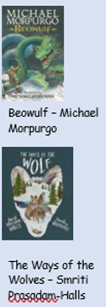 | 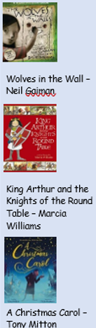 | 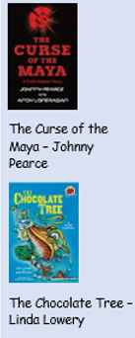 | 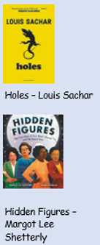 | 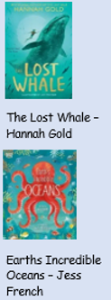 | 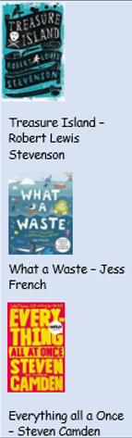
 | Purpose and Audience | Describe  Entertain  Inform | Entertain  Inform | Entertain  Instruct | Entertain  Inform  Persuade | Entertain  Inform  Instruct | Entertain  Inform
 | Writing Outcomes | Setting description  Diary entry  Informal letter | Formal letter  Narrative – to include speech  Report | Character description  Narrative  Instructions | Setting description  Informal letter  Persuasive leaflet | Character description  Narrative  Non-chronological report  Instructions | Narrative  Formal speech  Formal letter
 | Key Vocabulary Y5 | courage, descendants, prospered, reckless, brisk, foe, limb, lilting, envious, liar, warrior, vile, gruesome, hideous, grisly, dormitory, banish, plunge, downhearted, hilt, fiercest, grief, aloft, deeds, kinsman, grasped, fortunate, mound, venomous, staunch | plotting, schemes, ignorance, possessions, treasured, puppet, gnawing, creep, exposed, ignorance, pantry, huddled, astonishing, grumble, crept, smearing, dashing, banister, possession, brandishing, sustained,  miserly, chamber, chimed, nervously, humbug, foolish, gruel, gloom, mournful, merely, muttered, drear, rejecting, startling, scene, folk, bustling, gazing, pallid, frail, grimly, toiled, laboured, meagre, sorrow, spectre, merged, amends, heartily | Trudging, commonplace, mesmerising, vaulted, irate, errands, saunter, absent-minded, diminishing, arrogant, descend, loomed, communal, wide-berth, macabre, hastily, regurgitated, ungainly, exertion, alcove, tenacious, tribulations, astute, roughshod, remonstrating, haunches, manhandled, injustice, passive, ramifications, brooding, tempestuous, redolent, clandestine, ambivalent, disconcerting, irate, nonchalant, barrage, eminent, vivid, wry, vigour, pivotal, disdain, exuberant, scrutinise, warily, | Shrivelled, forbidden, befell, obstacle, slumped, stifling, consisted, burlap, barren, particularly, relieved, compound, attitude, realise, coincidence, torment, scarcity, unearthed, defective fleshy. Dawdle, grimaced, rotated, eternity, sprawled, radiated, vinyl, bulge, plopped, worthless, accomplish, figured, etched, glisten, haze, piercing, intently, busted, reciting, uncertainty, glanced, throbbing, widened, penetrating, jerked, gash, trailing, awakened, quack, credit, gratefully, murky, gathered, momentarily, blotchy, advise, indefinitely, hysterical, tedious, anchored | Register, enveloped, outskirts, reluctantly, flush, tentatively, prise, migration, sneery, ushered, shoal, laden, unruly, captivate, impulsively, indistinct, emerge, cursing, wildness, flailing, brief, majestically, flitting, startled, petite, adept, puzzled, pleading, burden, combing, ritual, eternal, strain, lingering, ominous, plead, gradually, coax, vulnerable, serenity, navigating, patrolling, queasy, | Lodging, coarsely, seafarer, companion, decline, cutlass, oath, mistily, hoist, deserted, deformed, overhauled, scatter, frenzy, plundered, odious, pluck, courage, credit, mutiny, distant, boasting, audible, faithful, landlocked, tiff, jiffy, ambush, cannibal, marooned, ringleader, dilly-dally, ebbs, stockade, isolated, idle, placid, truce, desertion, treachery, loophole, coracle, lopsided, revolves, comprehend, retreat, bucking, derision, deception, plunge, truancy, recoil, bygone, deposed, bumbling, brisk, captor, bearing, baited, skylarking, superstitious, excavated, liberty,
 | Key Vocabulary Y6 | courage, descendants, prospered, reckless, brisk, foe, limb, lilting, envious, liar, warrior, vile, gruesome, hideous, grisly, dormitory, banish, plunge, downhearted, hilt, fiercest, grief, aloft, deeds, kinsman, grasped, fortunate, mound, venomous, staunch | plotting, schemes, ignorance, possessions, treasured, puppet, gnawing, creep, exposed, ignorance, pantry, huddled, astonishing, grumble, crept, smearing, dashing, banister, possession, brandishing, sustained  miserly, chamber, chimed, nervously, humbug, foolish, gruel, gloom, mournful, merely, muttered, drear, rejecting, startling, scene, folk, bustling, gazing, pallid, frail, grimly, toiled, laboured, meagre, sorrow, spectre, merged, amends, heartily | Trudging, commonplace, mesmerising, vaulted, irate, errands, saunter, absent-minded, diminishing, arrogant, descend, loomed, communal, wide-berth, macabre, hastily, regurgitated, ungainly, exertion, alcove, tenacious, tribulations, astute, roughshod, remonstrating, haunches, manhandled, injustice, passive, ramifications, brooding, tempestuous, redolent, clandestine, ambivalent, disconcerting, irate, nonchalant, barrage, eminent, vivid, wry, vigour, pivotal, disdain, exuberant, scrutinise, warily, | Shrivelled, forbidden, befell, obstacle, slumped, stifling, consisted, burlap, barren, particularly, relieved, compound, attitude, realise, coincidence, torment, scarcity, unearthed, defective fleshy. Dawdle, grimaced, rotated, eternity, sprawled, radiated, vinyl, bulge, plopped, worthless, accomplish, figured, etched, glisten, haze, piercing, intently, busted, reciting, uncertainty, glanced, throbbing, widened, penetrating, jerked, gash, trailing, awakened, quack, credit, gratefully, murky, gathered, momentarily, blotchy, advise, indefinitely, hysterical, tedious, anchored | Register, enveloped, outskirts, reluctantly, flush, tentatively, prise, migration, sneery, ushered, shoal, laden, unruly, captivate, impulsively, indistinct, emerge, cursing, wildness, flailing, brief, majestically, flitting, startled, petite, adept, puzzled, pleading, burden, combing, ritual, eternal, strain, lingering, ominous, plead, gradually, coax, vulnerable, serenity, navigating, patrolling, queasy, | Lodging, coarsely, seafarer, companion, decline, cutlass, oath, mistily, hoist, deserted, deformed, overhauled, scatter, frenzy, plundered, odious, pluck, courage, credit, mutiny, distant, boasting, audible, faithful, landlocked, tiff, jiffy, ambush, cannibal, marooned, ringleader, dilly-dally, ebbs, stockade, isolated, idle, placid, truce, desertion, treachery, loophole, coracle, lopsided, revolves, comprehend, retreat, bucking, derision, deception, plunge, truancy, recoil, bygone, deposed, bumbling, brisk, captor, bearing, baited, skylarking, superstitious, excavated, liberty,
 | Grammar and Punctuation Y5 | Structure and organisation of text is informed by its audience, purpose and context.  Use paragraphs to organise information and ideas around a theme. Beginning to develop and expand some ideas and depth.  Use devices to build cohesion within a paragraph (e.g. then, after that, this, firstly).  Link ideas across paragraphs using adverbials of time (e.g. later), place (e.g. nearby) and number (e.g. secondly).  Use of tense choices to build cohesion across paragraphs.  Choose pronouns and nouns to aid cohesion and clarity to avoid repetition.  Ensure the consistent and correct use of tense throughout a piece of writing.  Ensure the correct subject and verb agreement when using singular and plural.  Write relative clauses beginning with who, which, where, whose, that or an omitted relative pronoun. | Structure and organisation of text is informed by its audience, purpose and context.  Use paragraphs to organise information and ideas around a theme. Beginning to develop and expand some ideas and depth.  Use devices to build cohesion within a paragraph (e.g. then, after that, this, firstly).  Link ideas across paragraphs using adverbials of time (e.g. later), place (e.g. nearby) and number (e.g. secondly).  Use of tense choices to build cohesion across paragraphs.  Choose pronouns and nouns to aid cohesion and clarity to avoid repetition.  Ensure the consistent and correct use of tense throughout a piece of writing.  Ensure the correct subject and verb agreement when using singular and plural.  Write relative clauses beginning with who, which, where, whose, that or an omitted relative pronoun.  Use expanded noun phrases to convey complicated information concisely. | Structure and organisation of text is informed by its audience, purpose and context.  Use paragraphs to organise information and ideas around a theme. Beginning to develop and expand some ideas and depth.  Use devices to build cohesion within a paragraph (e.g. then, after that, this, firstly).  Link ideas across paragraphs using adverbials of time (e.g. later), place (e.g. nearby) and number (e.g. secondly).  Use of tense choices to build cohesion across paragraphs.  Choose pronouns and nouns to aid cohesion and clarity to avoid repetition.  Ensure the consistent and correct use of tense throughout a piece of writing.  Ensure the correct subject and verb agreement when using singular and plural.  Write relative clauses beginning with who, which, where, whose, that or an omitted relative pronoun.  Use expanded noun phrases to convey complicated information concisely. | Structure and organisation of text is informed by its audience, purpose and context.  Use paragraphs to organise information and ideas around a theme. Beginning to develop and expand some ideas and depth.  Use devices to build cohesion within a paragraph (e.g. then, after that, this, firstly).  Link ideas across paragraphs using adverbials of time (e.g. later), place (e.g. nearby) and number (e.g. secondly).  Use of tense choices to build cohesion across paragraphs.  Choose pronouns and nouns to aid cohesion and clarity to avoid repetition.  Ensure the consistent and correct use of tense throughout a piece of writing.  Ensure the correct subject and verb agreement when using singular and plural.  Write relative clauses beginning with who, which, where, whose, that or an omitted relative pronoun.  Use expanded noun phrases to convey complicated information concisely.  Use brackets, dashes or commas to indicate parenthesis | Structure and organisation of text is informed by its audience, purpose and context.  Use paragraphs to organise information and ideas around a theme. Beginning to develop and expand some ideas and depth.  Use devices to build cohesion within a paragraph (e.g. then, after that, this, firstly).  Link ideas across paragraphs using adverbials of time (e.g. later), place (e.g. nearby) and number (e.g. secondly).  Use of tense choices to build cohesion across paragraphs.  Choose pronouns and nouns to aid cohesion and clarity to avoid repetition.  Ensure the consistent and correct use of tense throughout a piece of writing.  Ensure the correct subject and verb agreement when using singular and plural.  Write relative clauses beginning with who, which, where, whose, that or an omitted relative pronoun.  Use expanded noun phrases to convey complicated information concisely.  Use brackets, dashes or commas to indicate parenthesis  Use commas to clarify meaning or avoid ambiguity.  Indicate degrees of possibility using adverbs [for example, perhaps, surely] or modal verbs [for example, might, should, will, must]. | Structure and organisation of text is informed by its audience, purpose and context.  Use paragraphs to organise information and ideas around a theme. Beginning to develop and expand some ideas and depth.  Use devices to build cohesion within a paragraph (e.g. then, after that, this, firstly).  Link ideas across paragraphs using adverbials of time (e.g. later), place (e.g. nearby) and number (e.g. secondly).  Use of tense choices to build cohesion across paragraphs.  Choose pronouns and nouns to aid cohesion and clarity to avoid repetition.  Ensure the consistent and correct use of tense throughout a piece of writing.  Ensure the correct subject and verb agreement when using singular and plural.  Write relative clauses beginning with who, which, where, whose, that or an omitted relative pronoun.  Use expanded noun phrases to convey complicated information concisely.  Use brackets, dashes or commas to indicate parenthesis  Use commas to clarify meaning or avoid ambiguity.  Indicate degrees of possibility using adverbs [for example, perhaps, surely] or modal verbs [for example, might, should, will, must].
 | Grammar and Punctuation Y6 | Structure and organisation of text show an awareness of audience, purpose and context.  Use paragraphs to develop and expand some ideas, descriptions, themes or events in depth.  Link ideas across paragraphs using a wider range of cohesive devices: repetition of a word or phrase, grammatical connections [e.g. the use of adverbials such as on the other hand, in contrast, or as a consequence], and ellipsis.  Include relative clauses using a wide range of relative pronouns (or an implied relative pronoun) to clarify and explain relationships between ideas.  Use expanded noun phrases to convey complicated information concisely. | Structure and organisation of text show an awareness of audience, purpose and context.  Use paragraphs to develop and expand some ideas, descriptions, themes or events in depth.  Link ideas across paragraphs using a wider range of cohesive devices: repetition of a word or phrase, grammatical connections [e.g. the use of adverbials such as on the other hand, in contrast, or as a consequence], and ellipsis.  Include relative clauses using a wide range of relative pronouns (or an implied relative pronoun) to clarify and explain relationships between ideas.  Use a range of punctuation accurately:  Ellipsis  Colon – to introduce a list  Semi-colon – within lists  Bullet points – to list information  Hyphens – to avoid ambiguity  Use a range of layout devices, such as headings, sub-headings, columns, bullets or tables, to structure text.  Use different structures typical of informal speech and structures appropriate for formal speech and writing [for example, the use of question tags: He’s your friend, isn’t he?, or the use of subjunctive forms such as If I were or Were they to come in some very formal writing and speech].  Use synonyms and antonyms and has a wide, rich range to draw on. | Structure and organisation of text show an awareness of audience, purpose and context.  Use paragraphs to develop and expand some ideas, descriptions, themes or events in depth.  Link ideas across paragraphs using a wider range of cohesive devices: repetition of a word or phrase, grammatical connections [e.g. the use of adverbials such as on the other hand, in contrast, or as a consequence], and ellipsis.  Include relative clauses using a wide range of relative pronouns (or an implied relative pronoun) to clarify and explain relationships between ideas.  Use a range of punctuation accurately:  Ellipsis  Colon – to introduce a list  Semi-colon – within lists  Bullet points – to list information  Hyphens – to avoid ambiguity  Use a range of layout devices, such as headings, sub-headings, columns, bullets or tables, to structure text.  Use different structures typical of informal speech and structures appropriate for formal speech and writing [for example, the use of question tags: He’s your friend, isn’t he?, or the use of subjunctive forms such as If I were or Were they to come in some very formal writing and speech].  Use synonyms and antonyms and has a wide, rich range to draw on. | Structure and organisation of text show an awareness of audience, purpose and context.  Use paragraphs to develop and expand some ideas, descriptions, themes or events in depth.  Link ideas across paragraphs using a wider range of cohesive devices: repetition of a word or phrase, grammatical connections [e.g. the use of adverbials such as on the other hand, in contrast, or as a consequence], and ellipsis.  Include relative clauses using a wide range of relative pronouns (or an implied relative pronoun) to clarify and explain relationships between ideas.  Use a range of punctuation accurately:  Ellipsis  Colon – to introduce a list  Semi-colon – within lists  Bullet points – to list information  Hyphens – to avoid ambiguity  Use a range of layout devices, such as headings, sub-headings, columns, bullets or tables, to structure text.  Use different structures typical of informal speech and structures appropriate for formal speech and writing [for example, the use of question tags: He’s your friend, isn’t he?, or the use of subjunctive forms such as If I were or Were they to come in some very formal writing and speech].  Use synonyms and antonyms and has a wide, rich range to draw on.  Use modal verbs and adverbs to indicate degrees of possibility, probability and certainty  Use a range of punctuation accurately:  semi-colon, colon and dash to mark the boundary between independent clauses [for example, It’s raining; I’m fed up] | Structure and organisation of text show an awareness of audience, purpose and context.  Use paragraphs to develop and expand some ideas, descriptions, themes or events in depth.  Link ideas across paragraphs using a wider range of cohesive devices: repetition of a word or phrase, grammatical connections [e.g. the use of adverbials such as on the other hand, in contrast, or as a consequence], and ellipsis.  Include relative clauses using a wide range of relative pronouns (or an implied relative pronoun) to clarify and explain relationships between ideas.  Use a range of punctuation accurately:  Ellipsis  Colon – to introduce a list  Semi-colon – within lists  Bullet points – to list information  Hyphens – to avoid ambiguity  Use a range of layout devices, such as headings, sub-headings, columns, bullets or tables, to structure text.  Use different structures typical of informal speech and structures appropriate for formal speech and writing [for example, the use of question tags: He’s your friend, isn’t he?, or the use of subjunctive forms such as If I were or Were they to come in some very formal writing and speech].  Use synonyms and antonyms and has a wide, rich range to draw on.  Use modal verbs and adverbs to indicate degrees of possibility, probability and certainty  Use a range of punctuation accurately:  semi-colon, colon and dash to mark the boundary between independent clauses [for example, It’s raining; I’m fed up]  Use the passive to affect the presentation of information in a sentence [for example, I broke the window in the greenhouse versus The window in the greenhouse was broken (by me)].  Use the perfect form of verbs to mark relationships of time and cause (noun + to have + past participle, for example: I have eaten, You will have eaten, They had eaten, Having eaten). | Structure and organisation of text show an awareness of audience, purpose and context.  Use paragraphs to develop and expand some ideas, descriptions, themes or events in depth.  Link ideas across paragraphs using a wider range of cohesive devices: repetition of a word or phrase, grammatical connections [e.g. the use of adverbials such as on the other hand, in contrast, or as a consequence], and ellipsis.  Include relative clauses using a wide range of relative pronouns (or an implied relative pronoun) to clarify and explain relationships between ideas.  Use a range of punctuation accurately:  Ellipsis  Colon – to introduce a list  Semi-colon – within lists  Bullet points – to list information  Hyphens – to avoid ambiguity  Use a range of layout devices, such as headings, sub-headings, columns, bullets or tables, to structure text.  Use different structures typical of informal speech and structures appropriate for formal speech and writing [for example, the use of question tags: He’s your friend, isn’t he?, or the use of subjunctive forms such as If I were or Were they to come in some very formal writing and speech].  Use synonyms and antonyms and has a wide, rich range to draw on.  Use modal verbs and adverbs to indicate degrees of possibility, probability and certainty  Use a range of punctuation accurately:  semi-colon, colon and dash to mark the boundary between independent clauses [for example, It’s raining; I’m fed up]  Use the passive to affect the presentation of information in a sentence [for example, I broke the window in the greenhouse versus The window in the greenhouse was broken (by me)].  Use the perfect form of verbs to mark relationships of time and cause (noun + to have + past participle, for example: I have eaten, You will have eaten, They had eaten, Having eaten).
 | Spelling Y5 | Contractions  Possessive apostrophe before and after s  The prefix before a root word starting with m or p, in– becomes im–.  The prefix before a root word starting with l, in– becomes il.  The prefix before a root word starting with r, in– becomes ir–.  The prefix re– means ‘again’ or ‘back’.  The prefix sub– means ‘under’  The prefix inter– means ‘between’ or ‘among’  The suffix –tion added onto verbs to form nouns  Adding –ly to adverbs. words ending in ‘y’ become ‘ily’ and ‘–le’ become ‘ly.’ | Word with the ’sh’ sound spelled ch. These words are French in origin.  Ending ‘–sion.’  Ending ‘–tious’.  Ending -cious  Ending -cial  Ending -tial | Ending -ant  Ending -ance/-ancy  Using -ent and -ence after soft c, g /j/ and qu.  Ending -ible and -able | Ending -ibly and -ably  Ending -fer with the suffixes -al, -ence, -ing and -ed  Silent letters k, g, w, m, p at the start  Words with silent letters e.g., island, doubt | Words with /ie/ after c  Words spelt with /ei/ after c  Words using the letter string ‘ough’  making the /aw/ sound.  Words using the letter strong ‘ough’ making the /ow/ or /oa/ sound  Words where the /sc/ makes the s sound e.g., scenic  Hyphenated words | Rarer GPCs: words with the /ai/ sound spelt ‘ei’ (vein), ‘eigh’ (eight), ‘aigh’ (straight) or ‘ey’ (they)  Homophones
 | Spelling Y6 | Ending -sion/-ssion  Ending –tious  Ending -cious  Ending -cial  Ending -tial  Ending -ant  Ending -ance/-ancy  Ending -ible/ibly and -able/ably | Words with a soft c spelt -ce/-cy and -se/-sy at the end  Silent letters k, g, w, m, p at the start  Words with silent letters e.g., island, doubt  Words with /ie/ after c  Words spelt with /ei/ after c  Words using the letter string ‘ough’ making the /aw/ sound.  Words using the letter strong ‘ough’ making the /ow/ or /oa/ sound  Words where the /sc/ makes the s sound e.g., scenic | Prefixes -im, -il, -ir  Prefixes -re, -sub, -inter  Prefixes -auto and -ver  Words beginning with ‘acc’ e.g., accompany | Where soft c sound is made when a -c is followed by an e, I or y  Words spelt with -ph  Homophones | Revisit hyphenated words  Rarer GPCs: words with the /ai/ sound spelt ‘ei’ (vein), ‘eigh’ (eight), ‘aigh’ (straight) or ‘ey’ (they)  Words with /ie/ after c  Words spelt with /ei/ after c  Words using the letter string ‘ough’ making the /aw/ sound.  Homophones | Statutory spelling list words
 | Core Text Reading
 | Reading Skills Y5 | Word Reading / Fluency  *Apply their growing knowledge of root words, prefixes and suffixes, both to read aloud and to understand the meaning of new words.  *Preparing poems and plays to read aloud and to perform, showing understanding through intonation, tone and volume so that the meaning is clear to the audience.  Vocabulary  *Explore the meaning of words in context, confidently using a dictionary.  *Discuss how the author’s choice of language impacts the reader.  *Evaluate the authors use of language.  *Investigate alternative word choices that could be made.  *Begin to look at the use of figurative language.  *Use a thesaurus to find synonyms for a larger variety of words.  *Re-write passages using alternative word choices.  *Read around the word and explore its meaning in the broader context of a section or paragraph.  Inference  *Drawing inferences such as inferring characters’ feelings, thoughts and motives from their actions, and justifying inferences with evidence.  *Make inferences about actions, feelings, events or states.  *Use figurative language to infer meaning.  *Give one or two pieces of evidence to support the point they are making.  *Begin to draw evidence from more than one place across a text.  Prediction  *Predicting what might happen from details stated and implied.  *Support predictions with relevant evidence from the text.  *Confirm and modify predictions as they read on.  Explain  *Provide increasingly reasoned justification for my views.  *Recommend books for peers in detail  *Give reasons for authorial choices.  *Begin to challenge points of view.  *Begin to distinguish between fact and opinion.  *Identifying how language, structure and presentation contribute to meaning.  *Discuss and evaluate how authors use language, including figurative language, considering the impact on the reader.  *Explain and discuss their understanding of what they have read, including through formal presentations and debates.  Retrieve  *Confidently skim and scan, and also use the skill of reading before and after to retrieve information (read around).  *Use evidence from across larger sections of text.  *Read a broader range of texts including myths, legends, stories from other cultures, modern fiction and archaic texts.  *Retrieve, record and present information from non-fiction texts.  *Ask my own questions and follow a line of enquiry.  Sequence / Summarise  *Summarising the main ideas drawn from more than one paragraph, page, chapter or the entire text identifying key details to support the main ideas.  *Make connections between information across the text and include this is an answer.  *Discuss the themes or conventions from a chapter or text.  *Identify themes across a wide range of writing.
 | Reading Skills Y6 | Word Reading / Fluency  *Apply their growing knowledge of root words, prefixes and suffixes, both to read aloud and to understand the meaning of new words.  *Preparing poems and plays to read aloud and to perform, showing understanding through intonation, tone and volume so that the meaning is clear to the audience.  Vocabulary  *Evaluate how the authors’ use of language impacts upon the reader.  *Find examples of figurative language and how this impacts the reader and contributes to meaning or mood.  *Discuss how presentation and structure contribute to meaning.  *Explore the meaning of words in context by ‘reading around the word’ and independently.  *Explore its meaning in the broader context of a section or paragraph.  Inference  *Drawing inferences such as inferring characters’ feelings, thoughts and motives from their actions, and justifying inferences with evidence.  *Discuss how characters change and develop through texts by drawing inferences based on indirect clues.  *Make inferences about events, feelings, states backing these up with evidence.  *Infer characters’ feelings, thoughts and motives, giving more than one piece of evidence to support each point made. They can draw evidence from different places across the text.  Prediction  *Predicting what might happen from details stated and implied.  *Support predictions by using relevant evidence from the text.  *Confirm and modify predictions in light of new information.  Explain  *Provide increasingly reasoned justification for my views.  *Recommend books for peers in detail.  *Give reasons for authorial choices.  *Begin to challenge points of view.  *Begin to distinguish between fact and opinion.  *Identifying how language, structure and presentation contribute to meaning.  *Discuss and evaluate how authors use language, including figurative language, considering the impact on the reader.  *Explain and discuss their understanding of what they have read, including through formal presentations and debates.  *Distinguish between fact and opinion explaining how they know this.  Retrieve  *Children confidently skim and scan, and also use the skill of reading before and after to retrieve information (read around) *They use evidence from across whole chapters or texts.  *Read a broader range of texts including myths, legends, stories from other cultures, modern fiction, plays, poetry and archaic texts.  *Retrieve, record and present information from a wide variety of non-fiction texts. *Ask my own questions and follow a line of enquiry.  Sequence / Summarise  *Summarise information from across a text and link information by analysing and evaluating ideas between sections of the text.  *Summarising the main ideas drawn from more than one paragraph, identifying key details to support the main ideas.  *Make comparisons across different books. *summarise entire texts, in addition to chapters or paragraphs, using a limited amount of words or paragraphs.

