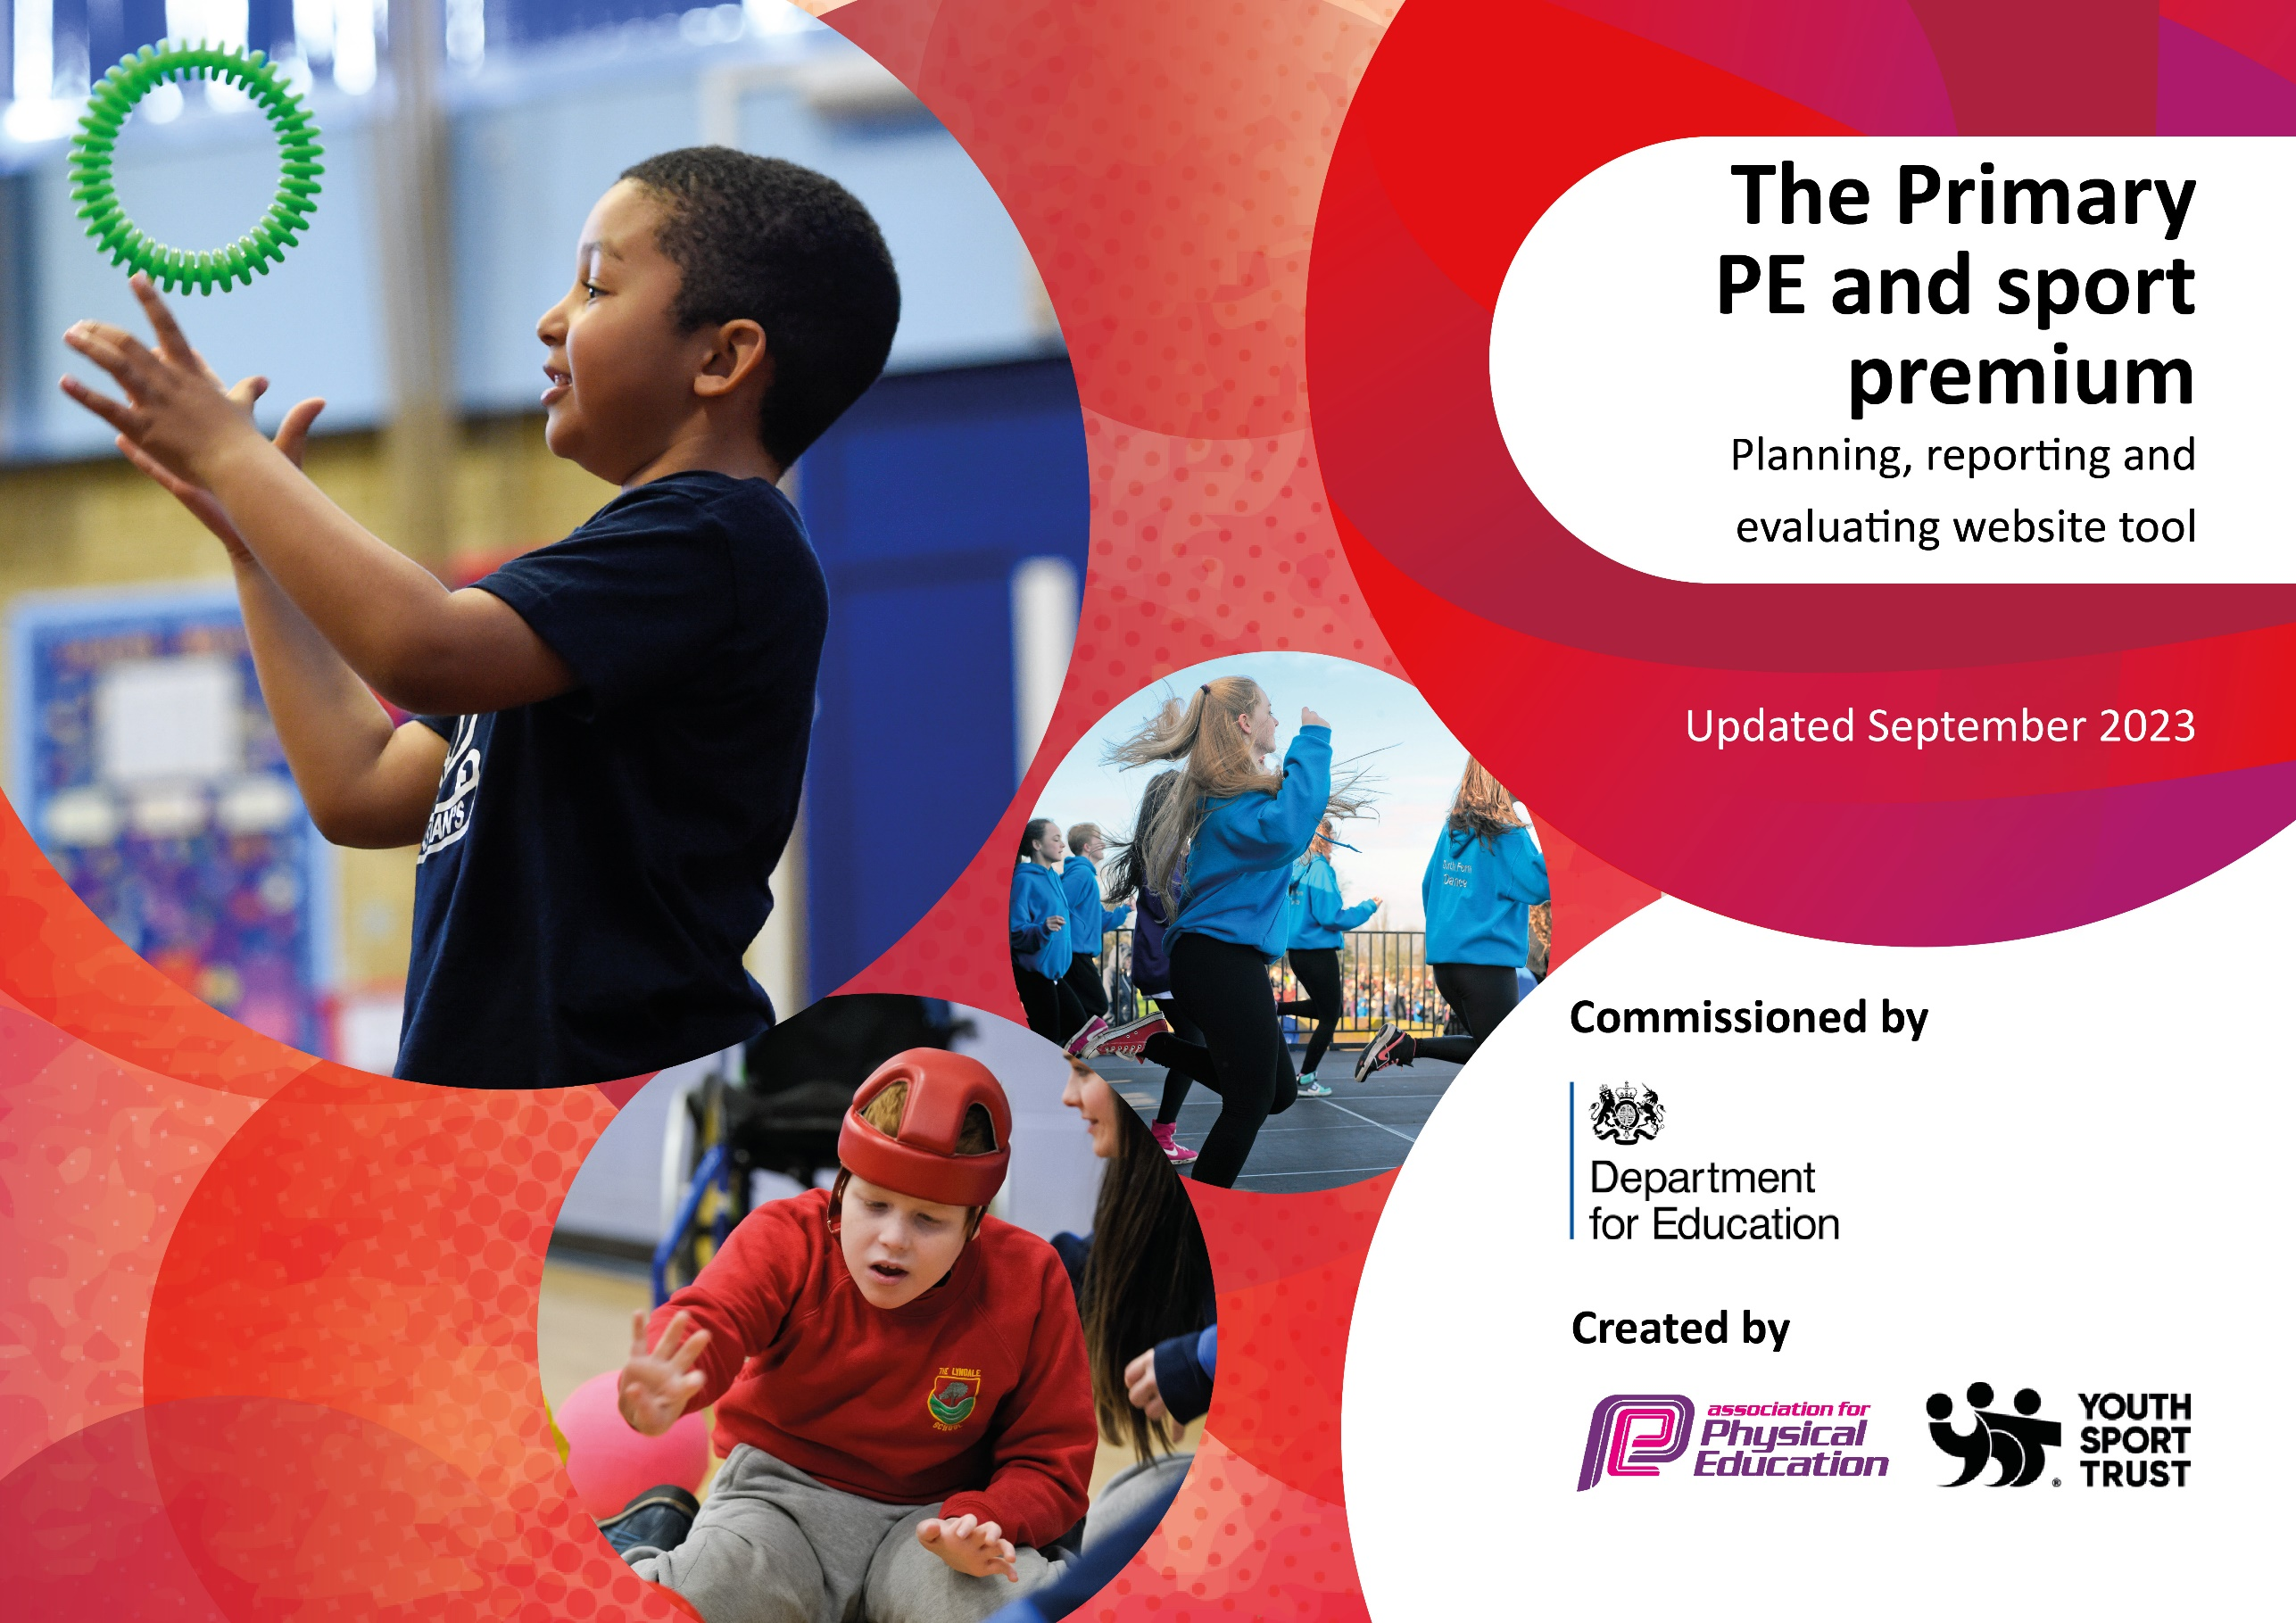

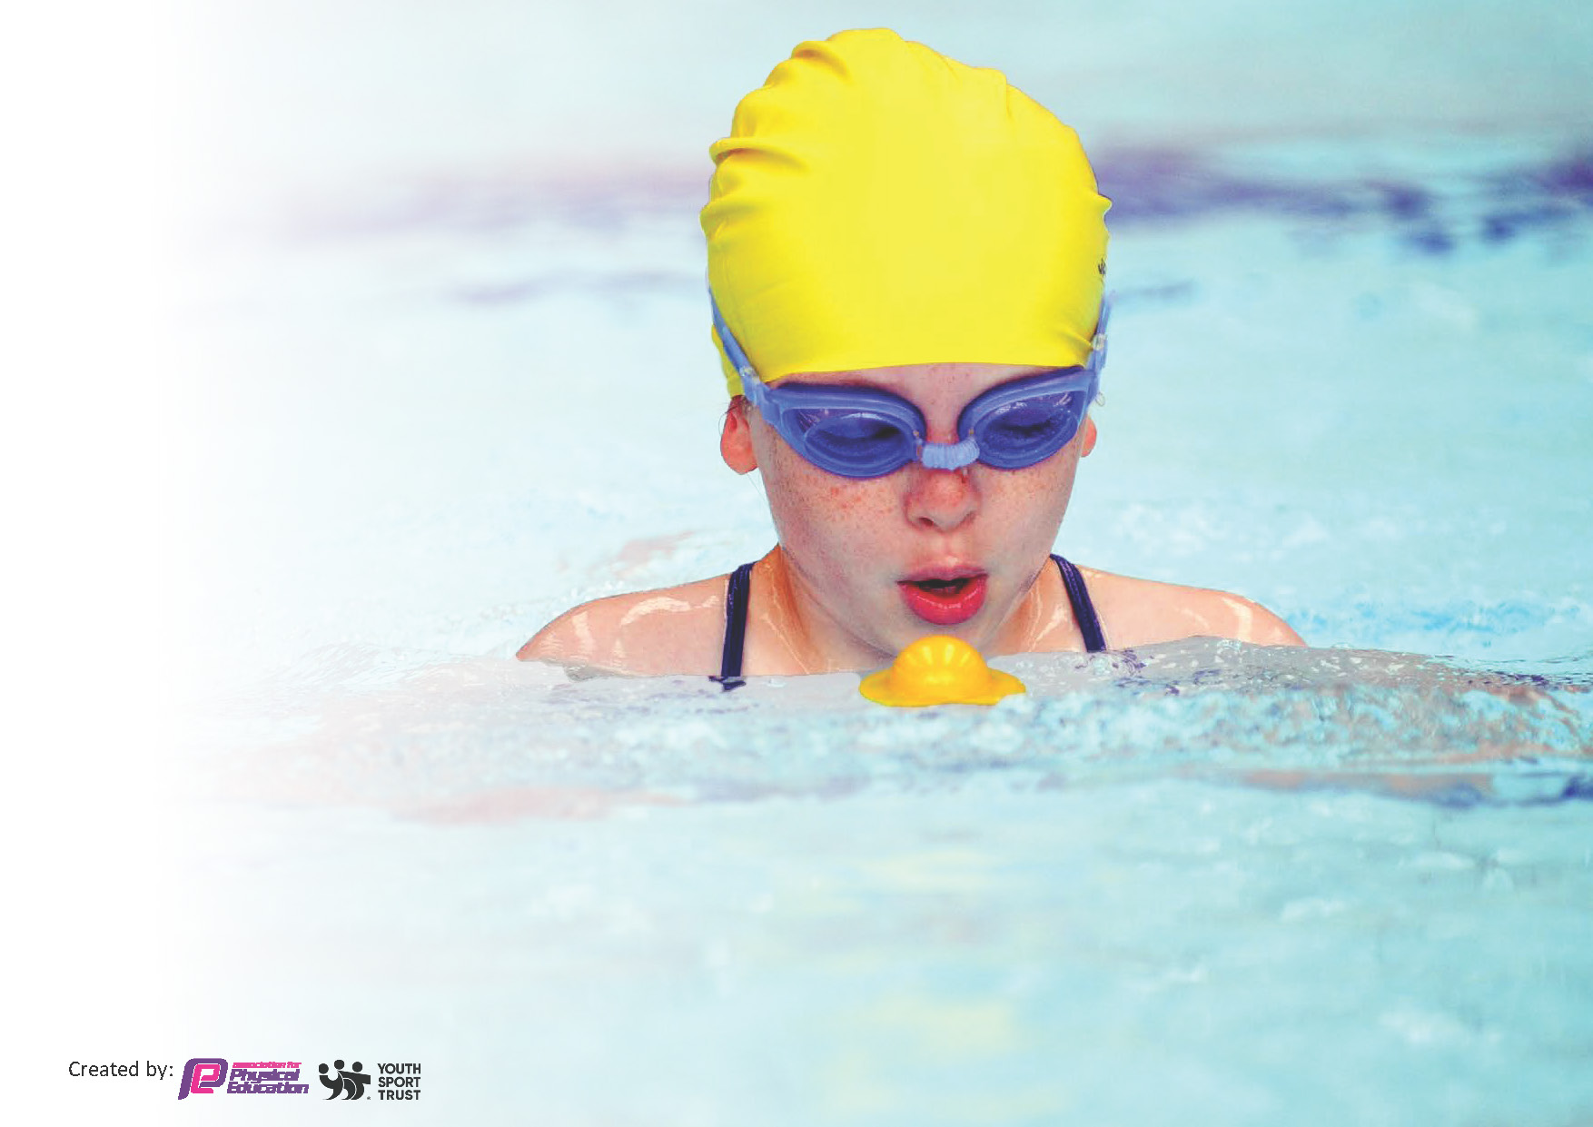
This template can be used for multiple purposes:
by:
- It enables schools to effectively plan their use of the Primary PE and sport premium
- It helps schools to meet the requirements (as set out in guidance) to publish information on their Primary PE and sport premium
- It will be an effective document to support Ofsted inspections enabling schools to evidence progress in Physical Education (PE) and evidence swimming attainment, which forms part of the PE National Curriculum. We would recommend schools consider
the Intent, Implementation and Impact of any spend, as examined within the Education Inspection Framework.

It is important that your grant is used effectively and based on school need.

Schools must use the funding to make additional and sustainable
improvements to the quality of the PE, School Sport and Physical Activity (PESSPA)
they offer. This means that you should use the Primary PE and sport premium to:

- Build capacity and capability within the school to ensure that improvements made now will benefit pupils joining the school in future years
- Develop or add to the PESSPA activities that your school already offers.

The Primary PE and sport premium should not be used to fund capital spend projects; the school’s core budget should fund these. Further detail on capital expenditure can be found in the updated Primary PE and sport premium guidance.

The Primary PE and sport premium guidance, outlines 5 key priorities that funding should be used towards. It is not

necessary that spending has to meet all the key priorities, you should select the priorities that you aim to use any funding towards.

Although completing this template is not a requirement for schools, schools are required to publish details of how they spend this funding. Schools must also outline what the impact this funding has had on pupils’ PE and sport participation and attainment and how any spending will be sustainable in the future. All funding must be spent by 31st July 2024.

The Department for Education has worked closely with the Association for Physical Education (afPE) and the Youth Sport Trust (YST) to develop this template and encourages schools to use it. This template is an effective way of meeting the reporting requirements of the Primary PE and sport premium.

Key priorities and Planning

Academic Year: 2023/2024 | Total fund allocated: | Date Updated:
Key indicator 1: The engagement of all pupils in regular physical activity – Chief Medical Officers guidelines recommend that primary school pupils undertake at least 30 minutes of physical activity a day in school |  |  |  | Percentage of total allocation: 80%
Intent | Implementation |  | Impact
Your school focus should be clear what you want the pupils to know and be able to do and about  what they need to learn and to  consolidate through practice: | Make sure your actions to achieve this are linked to your intentions: | Funding allocated: | Evidence of impact: what do pupils now know and what can they now do? What has changed? | Sustainability and suggested next steps:
To improve the quality of playtime and lunchtime provision for all pupils.  To reduce behaviour incidents during playtime and lunchtime.  To promote increased activity levels during lunch and breaktime.  To increase the breadth of sport activities available to children.  To ensure all children are involved in physical activity during the school  day.  To ensure children develop a good understanding of nutrition and living a healthy lifestyle. | Train Year 4 and Year 6 pupils to become playground leaders in order to improve constructive game play.  Update the ‘MUGA’ timetable.  Weekly dance after school club aimed at KS1.  Netball, football and cricket after school clubs targeted at KS2.  Spare PE kit available to children who have forgotten it.  Teachers will not remove PE lessons as a sanction.  Increase the breakfast club offer by applying for funding.  Hold assemblies relating to our school value of being healthy – mind and body. | £8439 | Pupils are active, healthy, enjoying the lunchtime activities and improving their skills. Play leaders have been trained by the PE lead and can now lead activities for other using a range of equipment.  A zoned approach to the outdoor space has provided pupils with opportunity to play team games in a safe environment, with enough space and resources.  Clear approach to the MUGA timetable ensures all pupils have the opportunity to access it in a safe an inclusive way. Due to this approach, participation levels are much higher, supporting with the active 50:50 agenda.  The dance club has proved to be popular throughout the year. Pupils have learnt several routines, with some now seeking to join a dance club in the community longer term.  Uptake on further extra-curricular sports clubs has been strong throughout the year, therefore exposing our pupils to a wide range of sporting activities and exposing them to a wider breadth and depth of sport.  Spare PE kit has ensured that all pupils are able to access PE lessons in school. This has removed some barriers to learning.  The school behaviour policy and timetables have been updated to ensure that missing PE is not a consequence. All pupils now have access to 2 sessions of PE per week.  A school breakfast club is now in place and every pupil across school has access to a free bagel upon coming into the school building each day. This ensures pupils have a healthy start to the day and are ready to learn. | Current leaders to support PE lead when training a new selection of sports leaders. Use pupil voice to analyse the opinions of the children. What did they enjoy? What was tough? Why? How could it be improved?  Continue with zoned plan, but encourage adults to become more actively engaged with the pupils. Communicate who our least physically active pupils are discretely target them during unstructured play times.  Contact a range of sports providers within the local community to strengthen links whilst maintaining the strong ones that have been fostered this year. Set up another comprehensive extra-curricular offer for next academic year.  Ensure all sure kit is clearly labelled and regularly washed for hygiene and sustainability reasons. Purchase a range of pumps as an appropriate footwear alternative.  Monitor impact of this throughout school as we move into the next academic year.  This has had a remarkably positive uptake, with 100% of pupils now being offered a healthy breakfast. Continue this into next academic year.

Key indicator 2: The profile of PESSPA being raised across the school as a tool for whole school improvement |  |  |  | Percentage of total allocation: 4%
Intent | Implementation |  | Impact
Your school focus should be clear what you want the pupils to know and be able to do and about  what they need to learn and to  consolidate through practice: | Make sure your actions to achieve are linked to your intentions: | Funding allocated: | Evidence of impact: what do pupils now know and what can they now do? What has changed? | Sustainability and suggested next steps:
More children to become engaged in a wider range of sports.  To raise the profile of inclusive sports. | Tennis coach.  Football Coach. | £422 | Pupils received a series of tennis sessions from a qualified tennis coach. The skills progression was clear throughout school and children enjoyed participating with the sessions.  Weekly football sessions took place with a focus on this being an inclusive sport. Adaptations were made to ensure all pails could access it and the profile of girls’ football was raised, supported by the success of the Lionesses.  Top Sportsability website shared with staff in order to support inclusion across the curriculum. | Pupils were signposted to tennis clubs in the local area following the sessions. Staff received CPD as part of the sessions and could now replicate this in school moving forward.  Awareness of staff and pupils has been raised and this is now evident in the playground and in PE lessons.  Teachers now able to refer to a clear, professional resources if further ideas are required. PE lead to contact OH of all EHCP pupils to ensure we are putting everything in place to ensure that they are successful.

Key indicator 3: Increased confidence, knowledge and skills of all staff in teaching PE and sport |  |  |  | Percentage of total allocation: 6%
Intent | Implementation |  | Impact
Your school focus should be clear | Make sure your actions to | Funding | Evidence of impact: what do | Sustainability and suggested
what you want the pupils to know | achieve are linked to your | allocated: | pupils now know and what | next steps:
and be able to do and about | intentions: |  | can they now do? What has
what they need to learn and to |  |  | changed?
consolidate through practice:
To increase the confidence of teaching staff when teaching and assessing PE.  To develop competency in assessment.  To ensure there is consistency across PE delivery. | Continue the implementation of the PE Scheme ‘Get Set for PE’ for staff to follow.  Develop a working display for PE in order for staff to communicate learning objectives and success criteria.  PE subject leader to complete EBE training and plan implementation for 24/25.  Subject leader release time to ensure consistent delivery. | £633 | New scheme implemented. Staff and pupil feedback on the scheme is positive and progression is now clear throughout the school. A new scheme has supported consistency of approach, and an increased level of ‘active learning’ is now taking place in PE.  New PE display is in a prominent place in the school hall. This is accessible to all year groups  EBE training completed by PE leader. Assessment for next academic year links to the taught curriculum.  PE able to identify areas for improvement and communicate these with staff in order to further strengthen the teaching of PE across school. | Continue to embed the new scheme into next academic year. Map out skills coverage for additional PE sessions and research ways to use the scheme to support movement interventions for those requiring additional sport to support with regulation or motor skills.  This will support with encouraging more peer and self-assessment, and will provide a vocabulary reference for teachers and pupils to refer to throughout sessions.  This will provide clear data for the PE lead to analyse in order to raise standards of teaching and learning in PE.  Continue to carry this out frequently to ensure high standards.

Key indicator 4: Broader experience of a range of sports and activities offered to all pupils |  |  |  | Percentage of total allocation: 5%
Intent | Implementation |  | Impact
Your school focus should be clear | Make sure your actions to | Funding | Evidence of impact: what do | Sustainability and suggested
what you want the pupils to know | achieve are linked to your | allocated: | pupils now know and what | next steps:
and be able to do and about | intentions: |  | can they now do? What has
what they need to learn and to |  |  | changed?
consolidate through practice:
To expand the range of sports offered in PE lessons.  To introduce a range of inclusive sports.  To increase opportunities for after school activities. | Begin to teach PE on a 2-year cycle so children are exposed to a wider range of sports.  Visit from Featherston Rovers Wheelchair basketball to promote inclusivity.  Encourage school staff to volunteer to deliver a sport after school club. | £527 | Two-year cycle now implements for all phases. Pupils allocated two PE sessions per week as is recommended in the Ofsted research review. Skills and sports planned in to ensure strong coverage of NC objectives.  Pupils saw first-hand how everybody can access sport and that it can be remarkably inclusive with slight adaptations. Raised awareness of additional clubs on offer for disabled pupils in the local community and demonstrated the importance of resilience.  A range of clubs offered to pupils across school throughout the year. Competitive events have also been well attended and the pupil feedback from these has been remarkably positive. | Review the impact of the curriculum on engagement and attainment. Use pupil voice, observations and assessment data to inform.  Continue to promote inclusive sports in school. Look to attend a competitive event targeting inclusivity.  Repeat this action moving into next year. Begin a tracking system to monitor which pupils are taking part in clubs/events. Monitor least physically active pupils and undertake pupil voice with them to encourage them to try a new sport/activity.

Key indicator 5: Increased participation in competitive sport |  |  |  | Percentage of total allocation: 5%
Intent | Implementation |  | Impact
Your school focus should be clear | Make sure your actions to | Funding | Evidence of impact: what do | Sustainability and suggested
what you want the pupils to know | achieve are linked to your | allocated: | pupils now know and what | next steps:
and be able to do and about | intentions: |  | can they now do? What has
what they need to learn and to |  |  | changed?
consolidate through practice:
To increase the number of intra school competitions.  To increase the number of inter school tournaments. | Fund transport to enable school staff to attend competitions and support the children with this.  Develop a system of in school clubs and competitions to run throughout the year.  Paid for transport to attend competitive events/workshops. | £527 | A wide-range of both intra and inter competitive events have taken place this year. Pupils have enjoyed the opportunity to compete with others and have had the opportunity to action their learning in relation to school games values/sportsmanship. | Begin a tracking system to monitor which pupils are taking part in clubs/events. Monitor least physically active pupils and undertake pupil voice with them to encourage them to try a new sport/activity.

Swimming Data
Meeting National Curriculum requirements for swimming and water safety.
Priority should always be given to ensuring that pupils can perform safe self-rescue even if they do not fully meet the first two requirements of the National Curriculum programme of study

Question | Stats: | Further context  Relative to local challenges
What percentage of your current Year 6 cohort can swim competently, confidently and proficiently over a distance of at least 25 metres? | 16% | Many of our pupils have not accessed a swimming pool for either leisure or lessons prior to their time at CTA. They begin at a remarkably low baseline, yet make excellent progress throughout their sessions. Pool availability is in high demand in the area, making it difficult to secure additional sessions for our pupils. Mobility rates in the area are also high.
What percentage of your current Year 6 cohort can use a range of strokes effectively [for example, front crawl, backstroke, and breaststroke]? | 16%
What percentage of your current Year 6 cohort are able to perform safe self-rescue in different water-based situations? | 16%
If your schools swimming data is below national expectation, you can choose to use the Primary PE and sport premium to provide additional top-up sessions for those pupils that did not meet National Curriculum, requirements after the completion of core lessons. Have you done this? | Yes/No
Have you provided CPD to improve the knowledge and confidence of staff to be able to teach swimming and water safety? | Yes/No
Head Teacher: | Adam Dawson
Subject Leader or the individual responsible for the Primary PE and sport premium: | Beth Downing
Governor: | Sharon Maiden
Date: | 28.07.2024

